Name: G Venkata Goutham Reddy
Reg no: 192324265
CSA1064-SOFTWARE ENGINEERING
LAB OBSERVATION(OUTPUTS)

EXP- 1
Create a Kanban Board (Jira/Trello)
Aim
To create and simulate a Kanban workflow using Jira or Trello.
Procedure
1. Login to Jira/Trello.
2. Create a new Kanban board.
3. Create columns: To Do, In Progress, Done.
4. Add 2 to 3 tasks.
5. Move tasks across columns to simulate workflow.
6. Observe task progress.
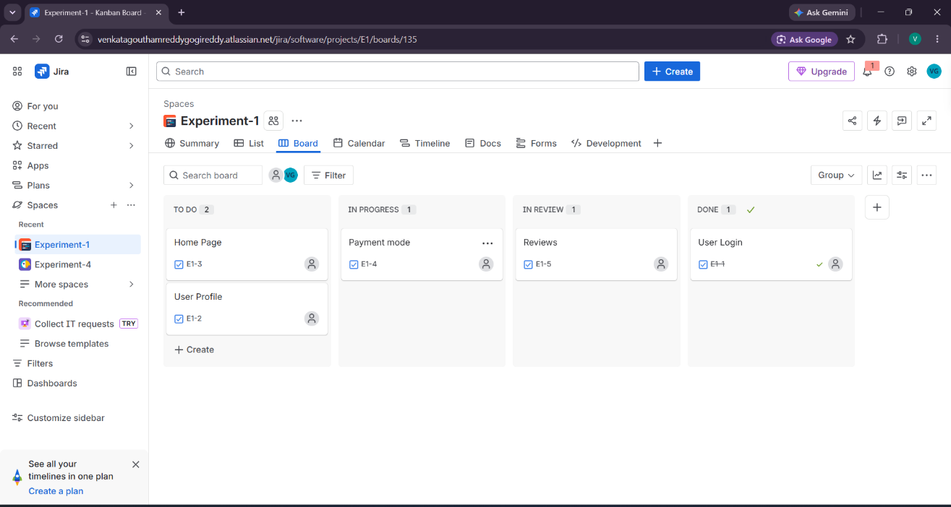

Result: Thus, The Kanban board has created successfully and simulated workflow by moving tasks across stages.
EXP- 2
Bus Ticket Booking Prototype (Figma)
Aim
To design a simple Bus Ticket Booking System prototype using Figma.
Procedure
1. Open Figma and create a new design file.
2. Design screens:
- Home Page
- Search Bus
- Seat Selection
- Payment Page
3. Add navigation links.
4. Present prototype mode.
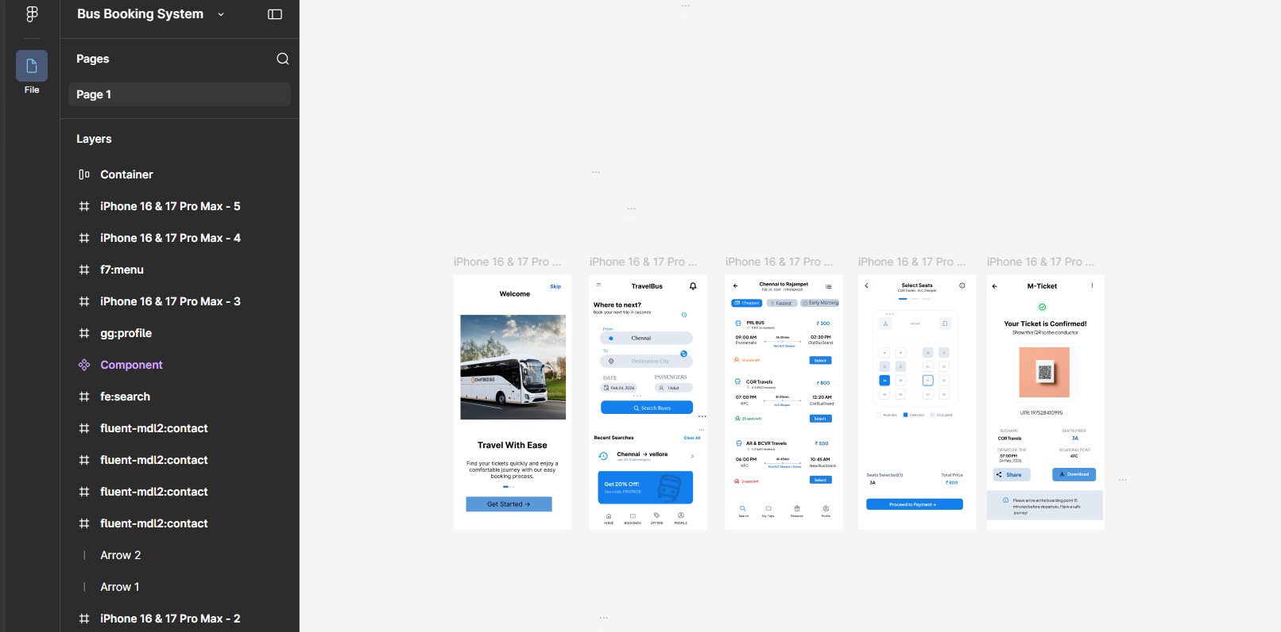
Result: Thus, The clickable prototype of Bus Ticket Booking System was created successfully.

EXP-3
E- Commerce Mobile App Prototype (Figma)
Aim
To design a prototype for stakeholder feedback.
Procedure
1. Create mobile frame in Figma.
2. Design Home, Product Page, Cart, Checkout.
3. Create two UI variations (to resolve conflict).
4. Present to stakeholders for feedback.
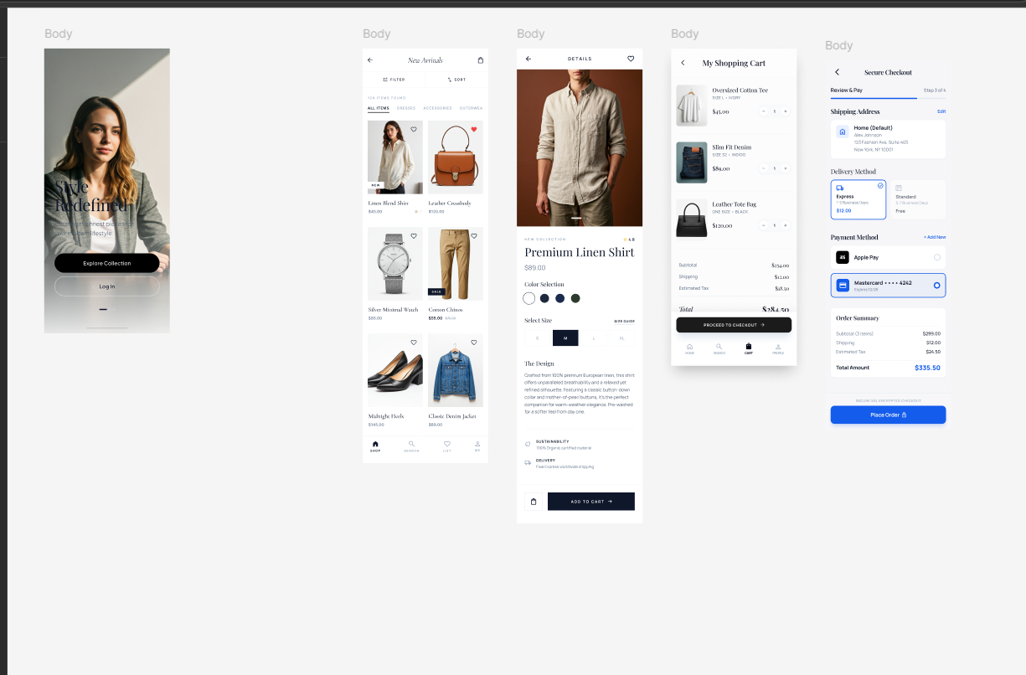
Result: Thus, The Prototype created and stakeholder feedback collected for UI finalization.

Exp-4:
Raptor- Total number of characters in the string

Aim
To create a RAPTOR flowchart to find and display the total number of characters in a given string.

Procedure
- Start the flowchart.
- Input a string from the user.
- Find the length of the string using the Length_Of() function.
- Display the total number of characters.
- Stop the flowchart.

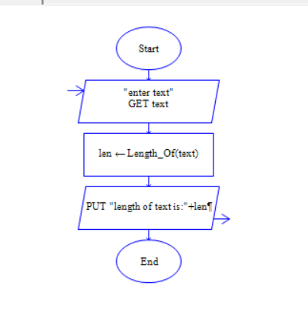
Result
Thus, the RAPTOR flowchart was successfully executed to display the total number of characters in the given string.

Exp-5
Raptor- lexicographically smallest string
Aim
To find the lexicographically smallest string by swapping two characters at most once using RAPTOR.
Procedure
- Input the string.
- Find two characters whose swap gives the smallest string.
- Swap all occurrences of those two characters.
- Display the new string.
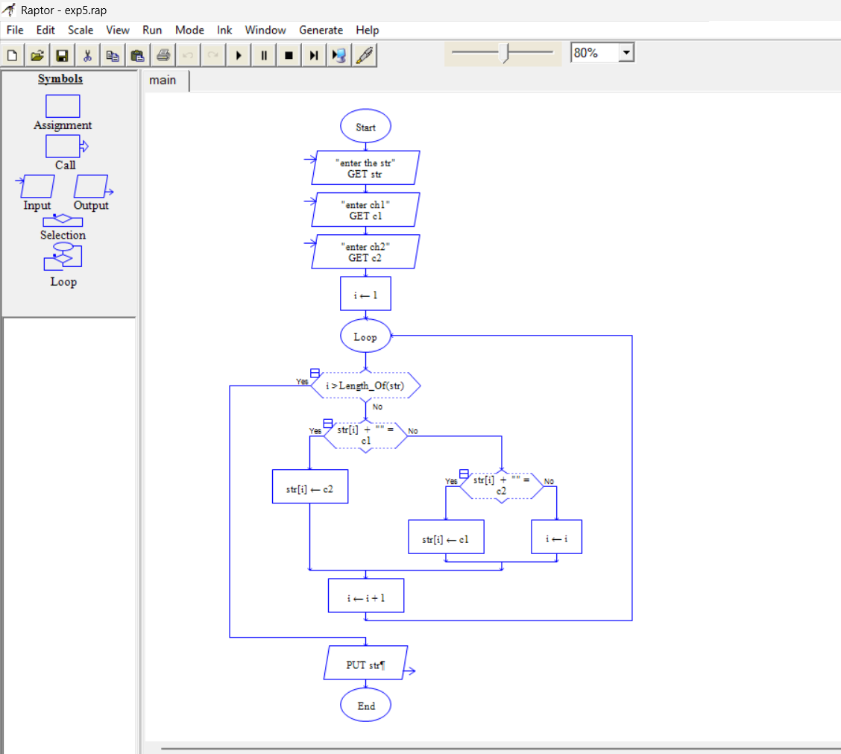
Result
Thus, the lexicographically smallest string was obtained successfully using RAPTOR.

Exp- 6:
Umbrello -Online Food Delivery System
Aim
To design UML diagrams for the Online Food Delivery System.
Procedure
- Study the requirements of the Online Food Delivery System.
- Identify the actors such as Customer, Restaurant, and Delivery Agent.
- Identify the classes, attributes, methods, and relationships.
- Draw the Class Diagram showing the structure of the system.
- Draw the Use Case Diagram showing interactions between actors and the system.
- Draw the Activity Diagram showing the flow from placing an order to delivery.
- Check and validate all diagrams for correctness.
- Save the completed diagrams.
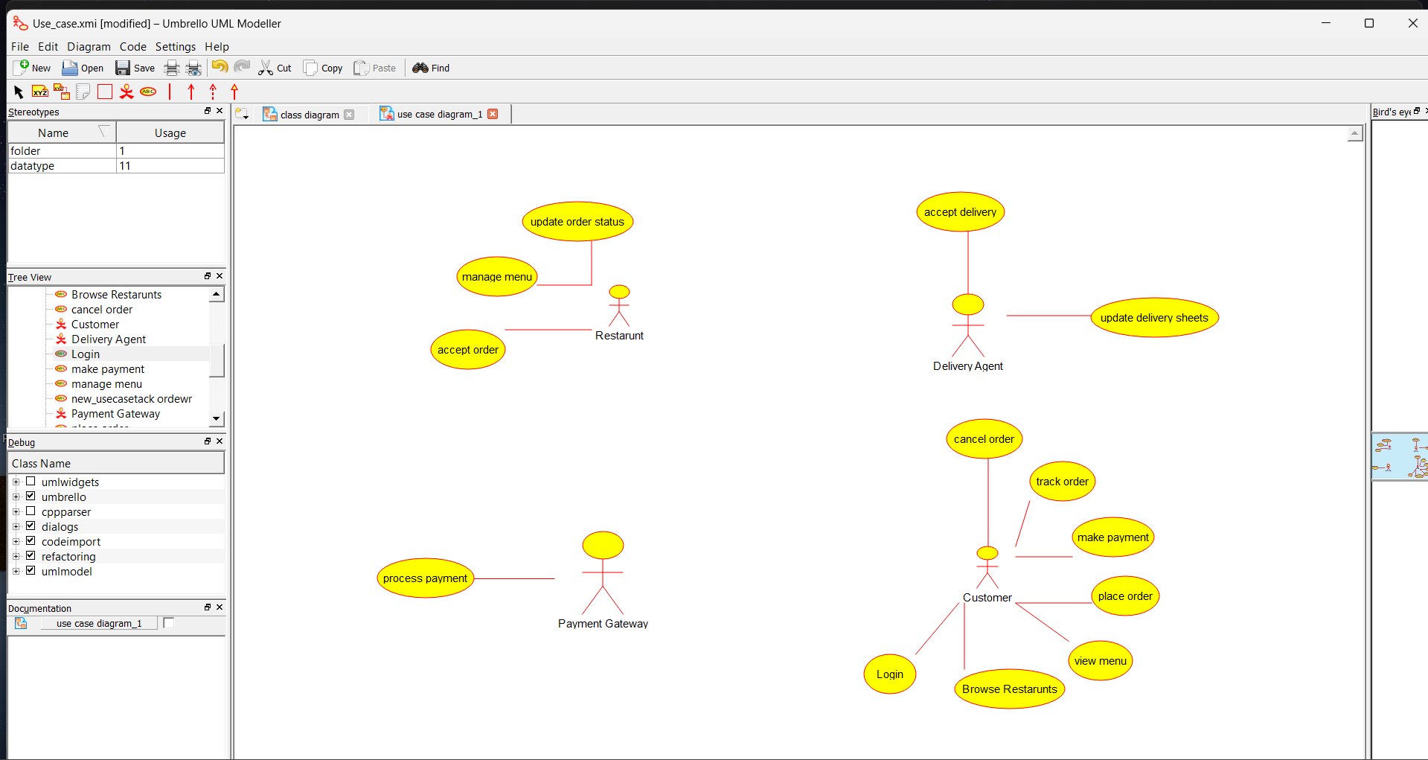

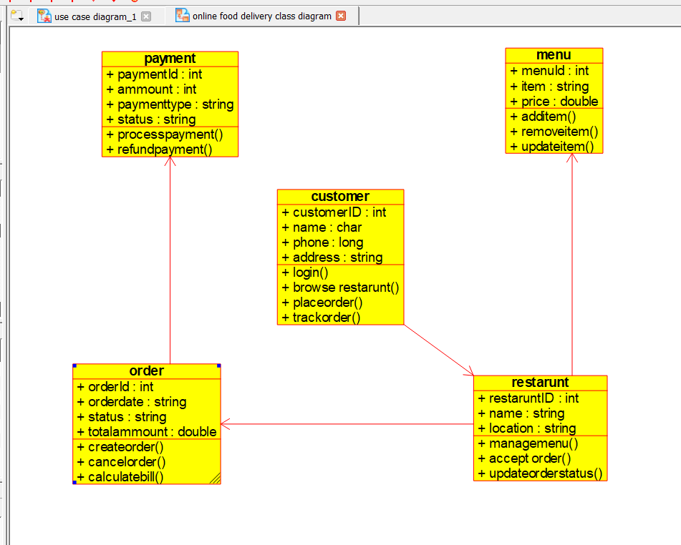
Result
Thus, the UML Class Diagram, Use Case Diagram, and Activity Diagram for the Online Food Delivery System were successfully designed and validated.

Exp- 7:
Umbrello-Online Security Management System.
Aim
To design UML diagrams for the Online Security Management System.
Procedure
- Study the requirements of the Online Security Management System.
- Identify the actors such as Admin, Security Personnel, and Payroll Management.
- Identify the classes, attributes, methods, and relationships involved in the system.
- Draw the Class Diagram showing the structure of the system including Security Personnel, Duty Schedule, Leave, and Salary modules.
- Draw the Use Case Diagram showing interactions between users and the system.
- Draw the Activity Diagram showing the workflow from duty allocation to leave processing and salary calculation.
- Check and validate all diagrams for correctness and completeness.
- Save the completed diagrams.
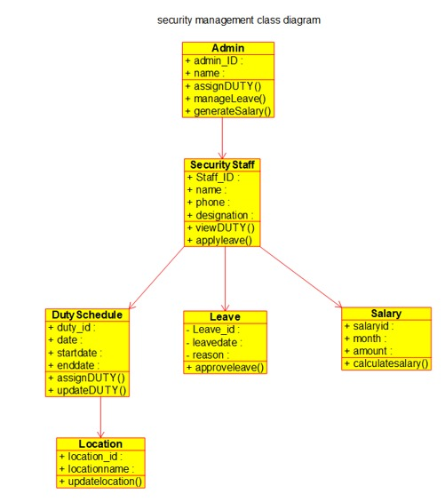
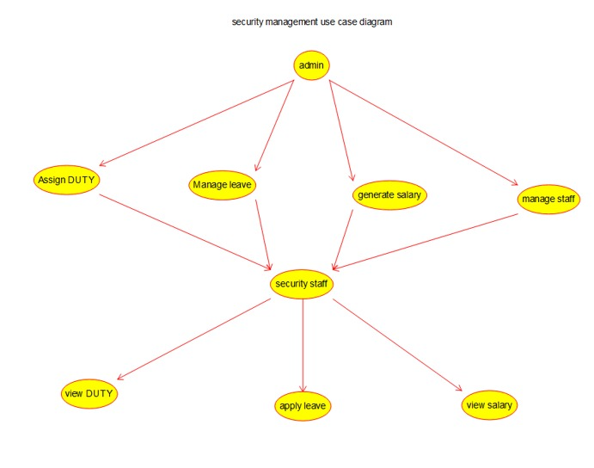
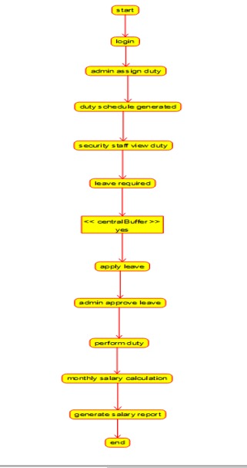
Result
Thus, the UML diagrams (Class Diagram, Use Case Diagram, and Activity Diagram) for the Online Security Management System were designed successfully using Umbrello.

Exp- 8:
Raptor- Cyclomatic Complexity in Software Testing
Aim
To find the Cyclomatic Complexity of the given flow graph.
Procedure
- Take the given values: E = 17, N = 13, P = 5.
- Use the formula: V(G) = E − N + 2.
- Substitute the values: V(G) = 17 − 13 + 2.
- Calculate the result: V(G) = 6.
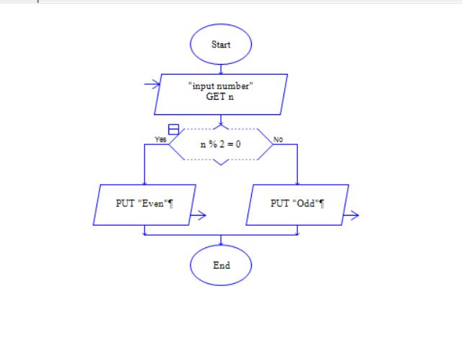
Result
Thus, the Cyclomatic Complexity of the flow graph is 6.

EXP -9:
Scrum Project in Jira
Aim
To create and manage a Scrum project in Jira.
Procedure
1. Create Scrum project.
2. Add 5 backlog items.
3. Prioritize backlog.
4. Create 1- week sprint.
5. Move tasks to sprint.
6. Start sprint.
7. Update task status until completion.
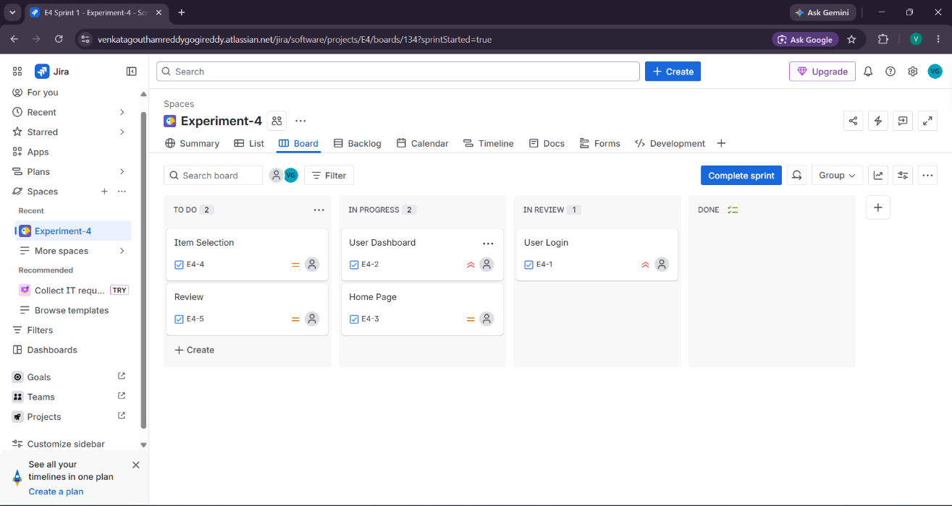

Result: Thus, The Scrum sprint executed successfully and sprint board tracked progress.

EXP- 10:
MoSCoW – Library Management System
Aim
To categorize requirements using MoSCoW method.
Procedure
1. List all requirements.
2. Analyze impact & feasibility.
3. Categorize into:
●Must Have , Should Have
●Could Have
●Won’t Have
4. Enter into Excel/Google Sheet.
5. Add justification column.
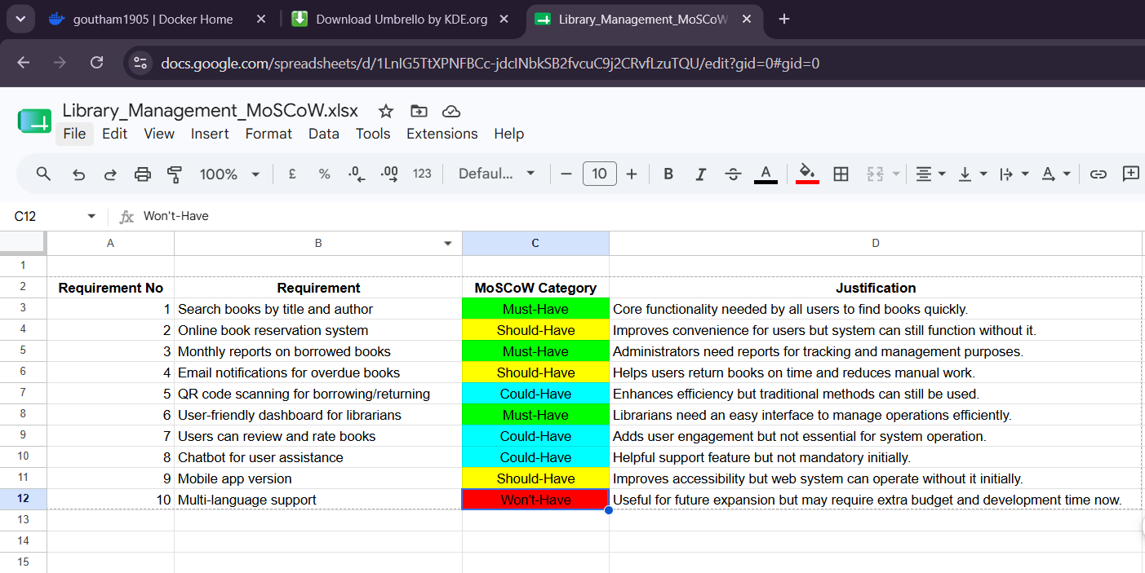
Result: Thus, The Requirements categorized successfully using MoSCoW prioritization

EXP- 11:
Link Jira with Confluence
Aim
To integrate Jira with Confluence for project tracking.
Procedure
- Create a jira project and choose scrum template.
- Enter a space name as Library Management System.
- Go to backlog and create 5 tasks in sprint.
- Start the sprint then, tasks will be shown.
- In side bar choose more option & choose confluence .
- Then the confluence page appears then, Create page in confluence.
- Then give any title. In the blank space type ‘/jira’.
- Click on jira legacy type the prompt ‘project=key order by status ASC’.
- Click enter and insert the task.
- Take a screenshot.
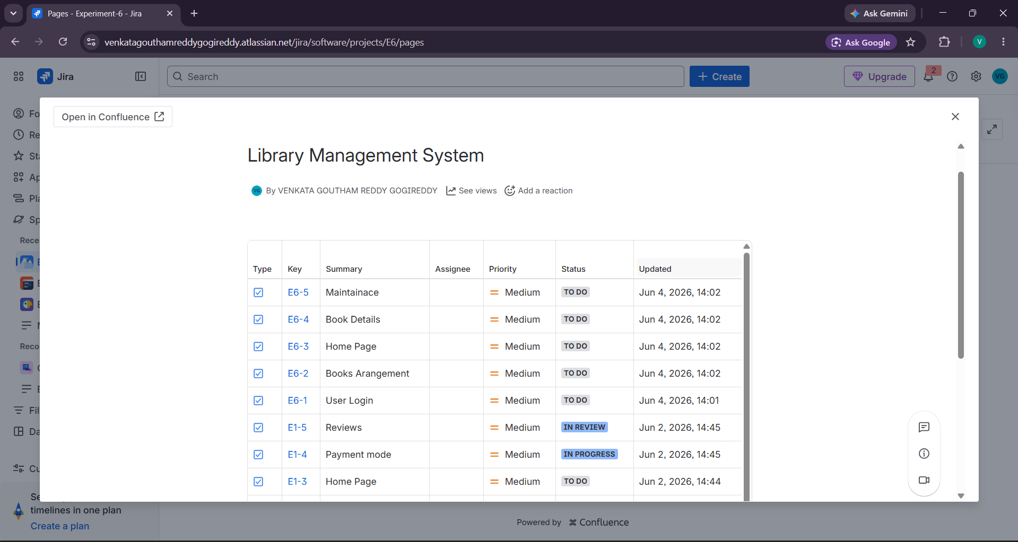
Result: Thus, The Jira issues embedded in Confluence with real- time progress tracking.

EXP- 12:
Task Management System – MoSCoW & Kano (Jira)
Aim
To prioritize system requirements using MoSCoW and Kano models.
Procedure
1. Create Jira project.
2. Add features as issues.
3. Categorize using MoSCoW.
4. Apply Kano model classification.
5. Document priority results.
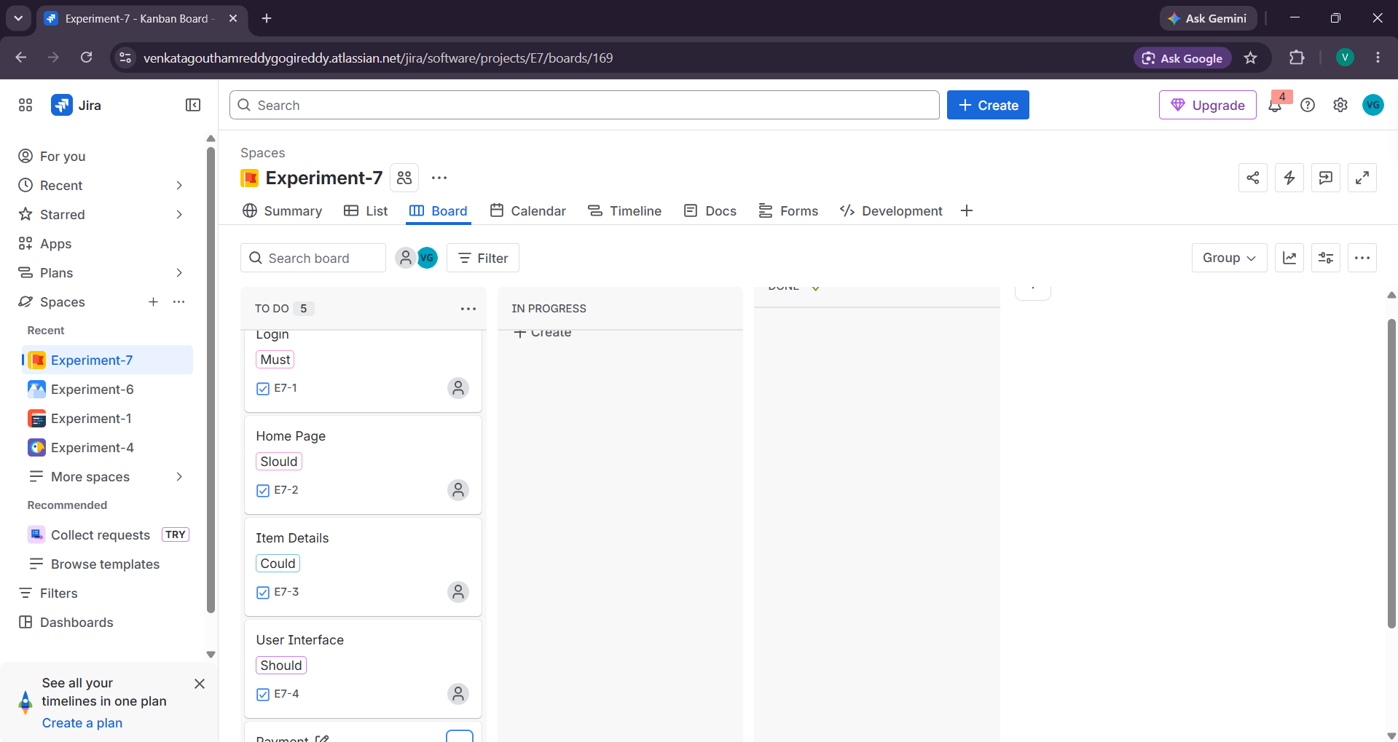

RESULT: Thus, The Requirements prioritized effectively using both models.

EXP- 13:
Online Learning Platform – MoSCoW & Kano
Aim
To categorize and prioritize platform requirements.
Procedure
1. Create Jira backlog.
2. Add all 6 features.
3. Categorize using MoSCoW.
4. Classify using Kano.
5. Prioritize accordingly.
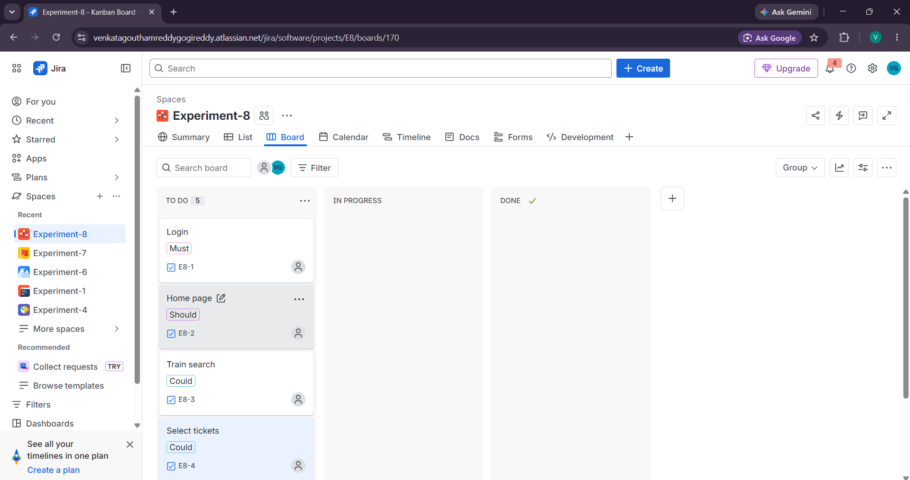

Result: Thus, The Features prioritized based on stakeholder value and satisfaction.

Exp- 14
Fork & Pull Request Workflow (GitHub)
Aim
To demonstrate collaboration using fork and pull request workflow.
Procedure
- Fork the Repository. Open GitHub and select a public repository. Click on the Fork option to create a copy in your account.
- Clone the Repository. Copy the forked repository URL. Use the command: git clone https://github.com/your-username/repository-name.git
- Create a New Branch , Navigate into the project folder and create a branch: git checkout -b feature-branch
- Make Changes Modify files such as adding a new function or updating README.
- Commit Changes ,Stage and commit the changes: git add .
git commit -m "Added new feature"
- Push Changes to GitHub git push origin feature-branch
- Create Pull Request
Go to GitHub → Click Compare & Pull Request .Add title and description → Create PR
- Review Process Team members review the code and provide suggestions.
- Update Based on Feedback Make necessary changes and push again:git add .
git commit -m "Updated based on review"
git push origin feature-branch
- Merge Pull Request After approval, click Merge Pull Request to merge changes into main branch.

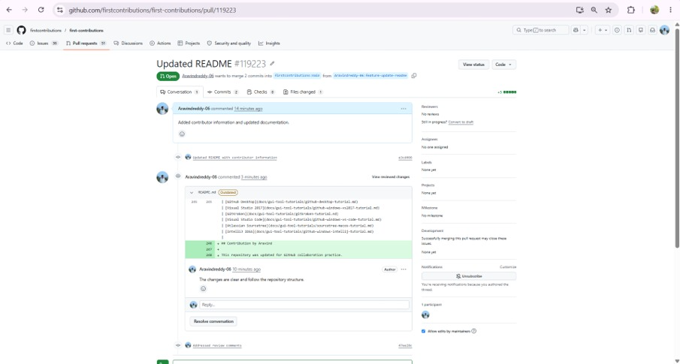

Result: Thus, The Pull request created and successfully merged after review.

EXP- 15
Git Branching & Merge Conflict
Aim
To resolve merge conflicts using Git.
Procedure
- Clone the Repository , git clone https://github.com/yourusername/repository-name.gitcd repository-name
- Create and Switch to New Branch git checkout -b feature-branch
- Make Changes Edit a file (e.g., README.md or code file)
- Commit Changes git add . git commit -m "Updated file in feature branch"
- Push Branch to GitHub git push origin feature-branch
- Pull Latest Changes from Main git checkout main git pull origin main
- Switch Back to Feature Branch git checkout feature-branch
- Merge Main into Feature Branch git merge main
- Resolve Merge Conflicts (if any) Open conflicting files
- Mark Conflicts as Resolved git add .
- Commit Merge Resolution git commit -m "Resolved merge conflict"
- Push Updated Branch & Create PR git push origin feature-branch Go to GitHub → Create Pull Request

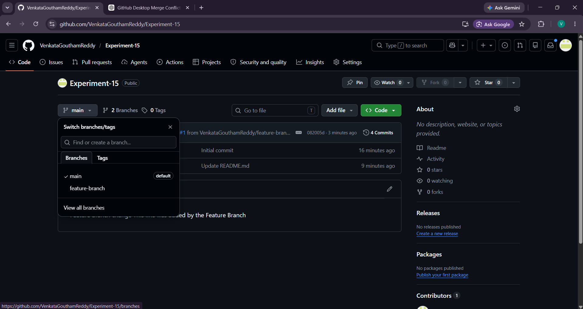

Result: Thus, The Merge conflicts resolved successfully and branch merged.

EXP- 16
Static Website with Docker
Aim
To containerize and serve a static website using Docker.
Procedure
1. Create a folder static-docker-website
2. Create a new file named index.html and paste this code
<!DOCTYPE html>
<html>
<head>
<title>My Docker Website</title>
</head>
<body style="text-align:center;font-family:Arial">
<h1>Hello from Docker Container 🚀</h1>
<h2>Static Website Running using Nginx</h2>
<p>This website is containerized using Docker.</p>
</body>
</html>
3.Create another named dockerfile and paste the code
FROM nginx:alpine
COPY index.html /usr/share/nginx/html/index.html
EXPOSE 80
4. Open new terminal and run this 'docker build -t my-static-website .'
5. In terminal run this command 'docker run -d -p 8080:80 my-static-website'
6. Open the browser and search 'http://localhost:8080'
7. In terminal type 'docker ps' and check the output.
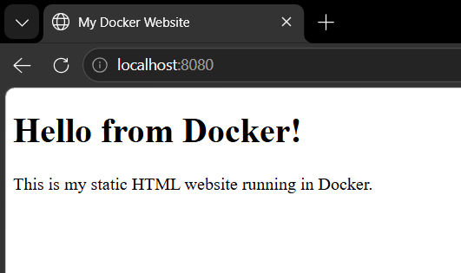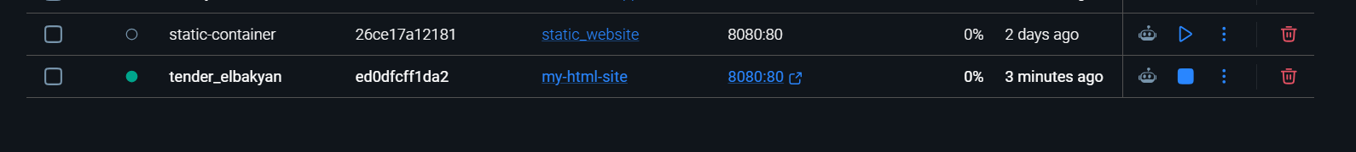

Result: Thus, The Static website successfully deployed in Docker container.

EXP- 17:
Flask API with Docker & Kubernetes
Aim
To deploy a Flask API using Docker and Kubernetes.
Procedure
1. Create a folder flask.api
2. create a file in that folder named app.py and paste this code.
from flask import Flask
app = Flask(__name__)
@app.route('/')
def home():
return "Hello from Flask API!"
@app.route('/about')
def about():
return "This is a simple Flask API"
if __name__ == '__main__':
app.run(host='0.0.0.0', port=5000)
3. Create another file named requirements.txt and write flask in that
4. Create another file named dockerfile and paste this code
FROM python:3.9
WORKDIR /app
COPY . /app
RUN pip install -r requirements.txt
EXPOSE 5000
CMD ["python", "app.py"]
5. Open terminal and run this docker build -t yourdockerhubusername/flask-api .
6. after run this in terminal docker images.
7. in terminal run this docker login
8. in same terminal run this command docker push yourdockerhubusername/flask-api
9. open kubernets in docker and click on create cluster and wait for 2 min
10. create a new file deployment.yaml and paste this code in that
apiVersion: apps/v1
kind: Deployment
metadata:
name: flask-deployment
spec:
replicas: 2
selector:
matchLabels:
app: flask-api
template:
metadata:
labels:
app: flask-api
spec:
containers:
- name: flask-container
image: yourusername/flask-api
ports:
- containerPort: 5000
11. create another file named service.yaml and paste the code
apiVersion: v1
kind: Service
metadata:
name: flask-service
spec:
type: NodePort
selector:
app: flask-api
ports:
- port: 5000
targetPort: 5000
nodePort: 30007
12. Open new terminal and run this two commands kubectl apply -f deployment.yaml and kubectl apply -f service.yaml
13. Then in terminal run kubectl get pods and kubectl get services
14. Open browser and check http://localhost:30007 and http://localhost:30007/about.
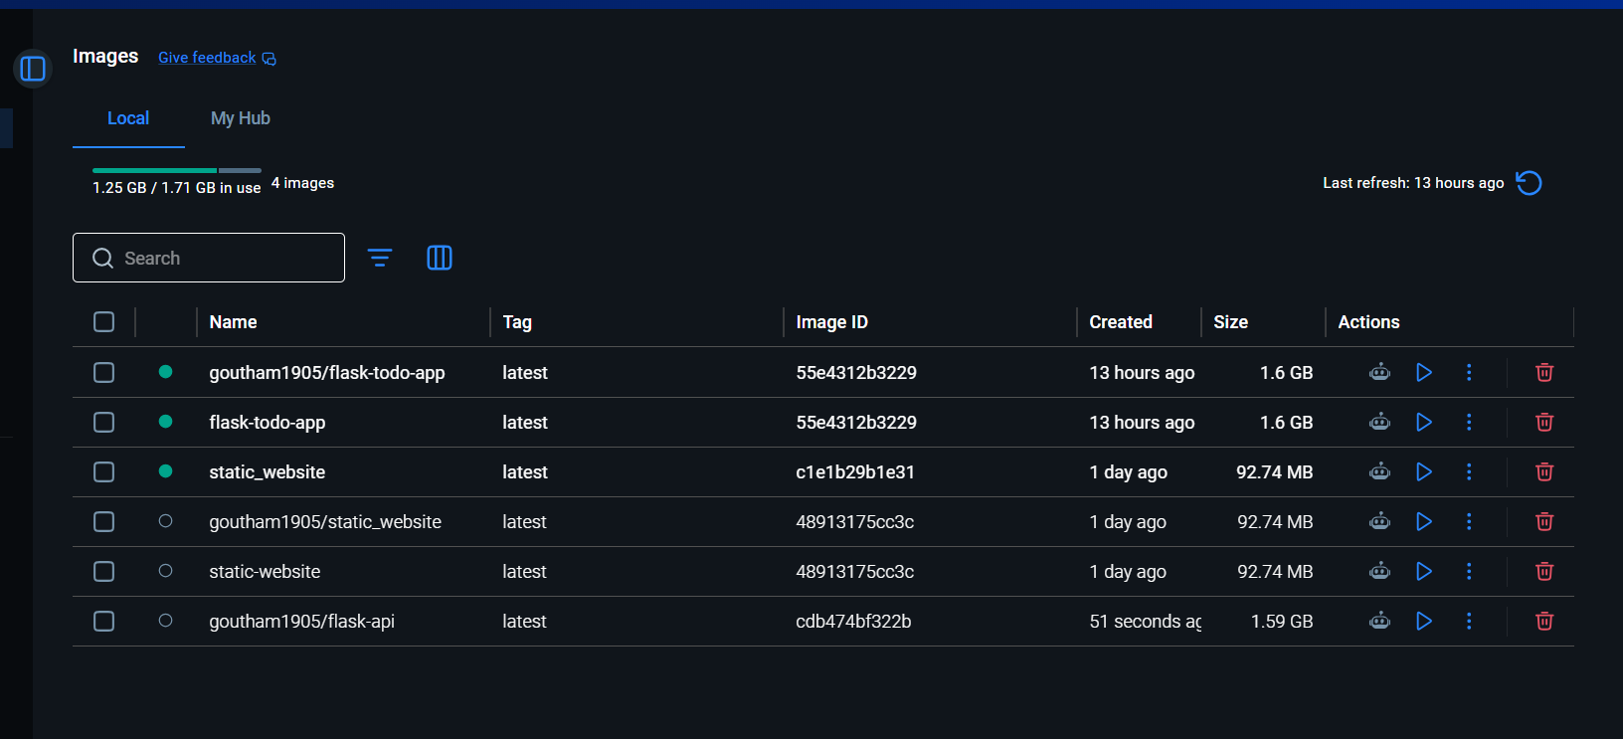
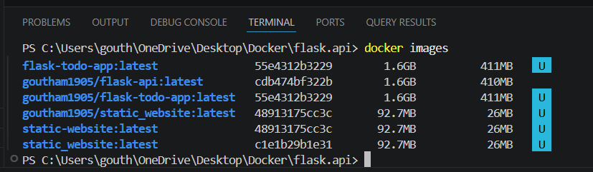

Result: Thus, The Flask API successfully deployed on Kubernetes cluster.

EXP- 18
CI/CD using Jenkins
Aim
To automate build and deployment using Jenkins.
Procedure
1. Create a new folder sample.app
2. Create a file app.py and paste the code.
from flask import Flask
app = Flask(__name__)
@app.route('/')
def home():
return "Hello from CI/CD Docker Pipeline!"
if __name__ == "__main__":
app.run(host='0.0.0.0', port=5000)
3. Create a file named requirements.txt and type flask in that
4. Create another new file named dockerfile and paste the code
FROM python:3.9
WORKDIR /app
COPY . /app
RUN pip install -r requirements.txt
EXPOSE 5000
CMD ["python", "app.py"]
5. Create a jenkinsfile and paste this code
pipeline {
agent any

stages {

stage('Clone Repository') {
steps {
git 'https://github.com/yourusername/sample-app.git'
}
}

stage('Build Docker Image') {
steps {
sh 'docker build -t sample-app .'
}
}

stage('Run Tests') {
steps {
sh 'echo Running Tests...'
}
}

stage('Deploy Container') {
steps {
sh 'docker run -d -p 5000:5000 sample-app'
}
}
}
}
6. Open the browser and type 'http://localhost:8081'
7. Unlock the Jenkins. In terminal run 'docker exec jenkins-container cat /var/jenkins_home/secrets/initialAdminPassword'
8.Copy the password and unlock the Jenkins click one the install plugins
7. Login to Jenkins and create admin user and click save and continue.
8. Jenkins dashboard appears and click one the create new item with any name and select pipeline below and click on ok.
9. Now configuration page opens scroll until you see pipeline section and paste code in script box
pipeline {
agent any

stages {

stage('Build Docker Image') {
steps {
sh 'docker build -t my-app .'
}
}

stage('Run Container') {
steps {
sh 'docker run -d -p 5000:5000 my-app'
}
}

}
}
10. Save it and click on build now. check the console output
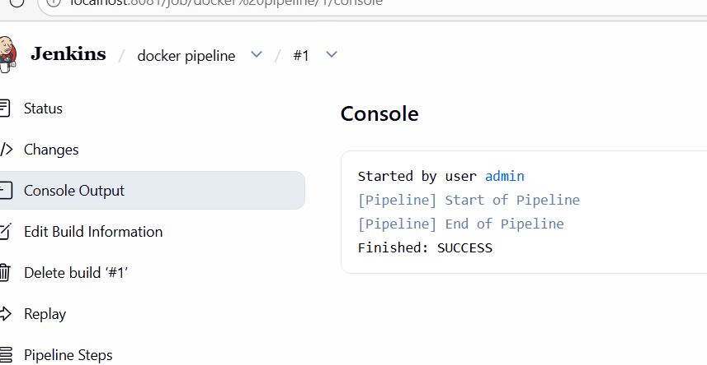
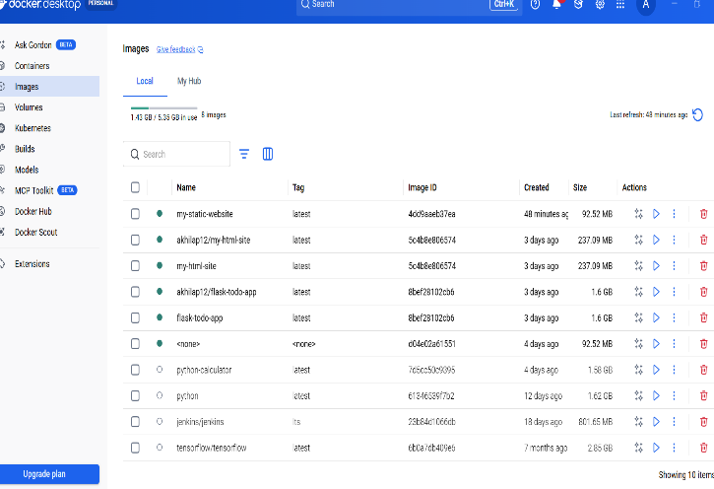

Result: Thus, The Static website successfully deployed in Docker container.

EXP- 19
Continuous Deployment with GitHub Actions
Aim
To automate Docker build and deployment using GitHub Actions.
Procedure
1. create a folder docker-github-actions-app
2. open it in vs code and create a file app.py and paste the code
from flask import Flask
app = Flask(__name__)
@app.route('/')
def home():
**return "Hello from GitHub Actions CI/CD Pipeline!"**if __name__ == "__main__":
**app.run(host="0.0.0.0", port=5000)**
3. create requirements.txt and write flask in that
4. create a file dockerfile and paste the code
FROM python:3.9
WORKDIR /app
COPY requirements.txt .
RUN pip install -r requirements.txt
COPY . .
CMD ["python","app.py"]
5. open new terminal and run this commands
git init
git add .
git commit -m "Initial commit"
6. open GitHub and create a new repository named docker-cicd-app
7. run this in the terminal
git remote add origin https://github.com/yourusername/docker-cicd-app.git
git branch -M main
git push -u origin main
8. so, expected output for task 1 is GitHub shows initial commit and 3 files added
9. click create new file in GitHub name it as .github/workflows/docker.yml
10. paste the code and click on commit new file
name: Docker CI/CD Pipeline
on:
push:
**branches: \[ "main" ]**
jobs:
build:
**runs-on: ubuntu-latest**
**steps:**
**- name: Checkout code**
**uses: actions/checkout@v3**
**- name: Login to DockerHub**
**uses: docker/login-action@v2**
**with:**
**username: ${{ secrets.DOCKER\_USERNAME }}**
**password: ${{ secrets.DOCKER\_PASSWORD }}**
**- name: Build Docker Image**
**run: docker build -t ${{ secrets.DOCKER\_USERNAME }}/cicd-app .**
**- name: Push Docker Image**
**run: docker push ${{ secrets.DOCKER\_USERNAME }}/cicd-app**
11. Then go to actions we will see Docker CI/CD Pipeline Workflow running... wait for some time till it completes.
12.so, expected output for task 2 is docker ci/cd workflow is showing success
13. Open settings on left side click on secrets and variables and click on repository secrets
14. in name give docker_username in secret giver yourdockerusername and click on add secret
15. again click on new repository secret and in name give docker_password and in secret write yourdockerpassword
16. for 4th task open vs code and modify the code of app.py instead of this return "Hello from GitHub Actions CI/CD Pipeline!" paste this return "CI/CD Pipeline Updated Successfully!"
17.in terminal run agiain this commands one by one, git pull origin main --allow-unrelated-histories, git add ., git commit -m "Updated project files" ,git push origin main
18. Then go to settings actions there we will see updated project files
19. in terminal run docker login and docker build -t yourusername/cicd-app .
19. in terminal docker push yourusername/cicd-app and docker run -d -p 5000:5000 username/cicd-app
20. open browser and check http://localhost:5000
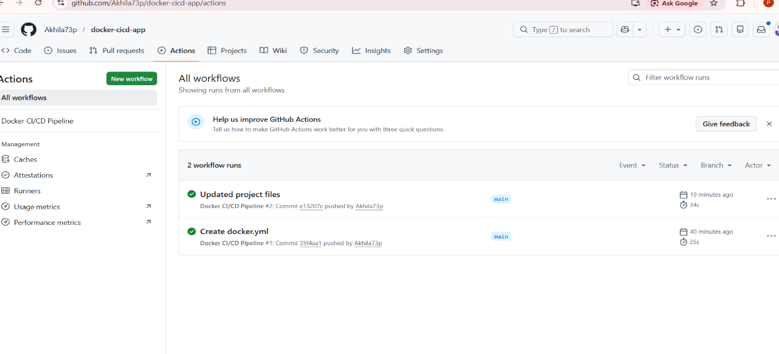

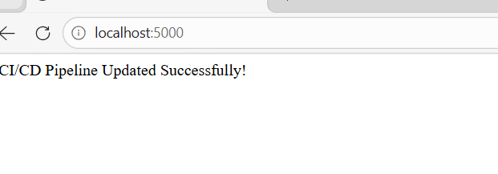

RESULT: Thus, The Application deployed automatically via GitHub Actions pipeline.

EXP- 20
GitHub Version Control
Aim
To implement version control workflow.
Procedure
1. Create a GitHub Repository Go to GitHub → Click New Repository , Enter repository name, description Select Public/Private , Click Create Repository
2. Clone Repository git clone https://github.com/your-username/repository-name.gitcd repository-name
3. Create Branches for Modules git checkout -b module1 git checkout -b module2
4. Work on Individual Modules Each team member works on their own branch Add code / update files
5. Commit Changes git add . git commit -m "Added module functionality"
6. Push Branches to GitHub git push origin module1 git push origin module2
7. Create Pull Requests Go to GitHub → Click Compare & Pull Request Add title & description Submit PR for review
10. Resolve Merge Conflicts (if any) Open conflicting files Edit and remove conflict markers: Then run: git add . git commit -m "Resolved conflicts"
11. Update README File Include: Project description , Team members
12. Push Final Changes git push origin main
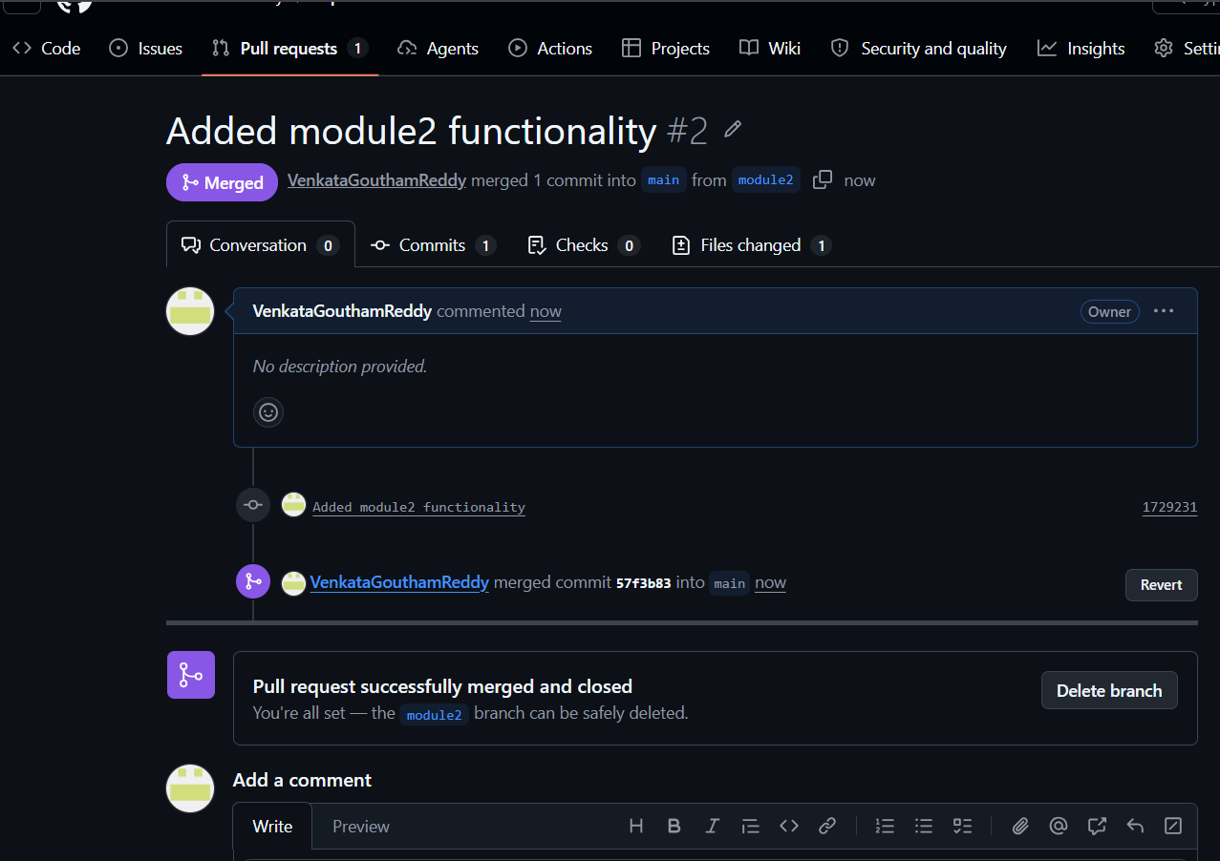
Result: Thus. The Merge conflicts resolved successfully and branch merged.
EXP- 21:
Containerize Flask To- Do App
Aim
To containerize Flask To- Do application.
Procedure
1.Create a folder named todo-flask-docker.
2. Open the folder in VS code.
3. Create a new file app.py and paste the code and save it.
from flask import Flask, request, redirect, url_for, render_template_string
app = Flask(__name__)
todos = []
html = """
<h2>My To-Do List</h2>
<form method="POST">
<input type="text" name="task" placeholder="Enter task">
<input type="submit" value="Add Task">
</form>
<ul>
{% for todo in todos %}
<li>{{todo}}</li>
{% endfor %}
</ul>
"""
@app.route("/", methods=["GET", "POST"])
def index():
if request.method == "POST":
task = request.form.get("task")
if task:
todos.append(task)
return redirect(url_for("index"))
return render_template_string(html, todos=todos)
if __name__ == "__main__":
app.run(host="0.0.0.0", port=5000)
4. Create another new file requirements.txt. Type Flask and save it.
5. Create another new file named dockerfile and paste this code and save it.
FROM python:3.10
WORKDIR /app
COPY . .
RUN pip install -r requirements.txt
EXPOSE 5000
CMD ["python", "app.py"]
6. Open new terminal and run ‘docker build -t flask-todo-app .’
7. After run this ‘docker run -d -p 5000:5000 flask-todo-app’
8. Open the browser and type ‘http://localhost:5000’ to see the output.
9. In terminal run ‘docker login’
10. To see the output in dockerhub type ‘docker tag flask-todo-app yourusername/flask-todo-app’ in the terminal.
11. To push the image ‘docker push yourusername/flask-todo-app’ type it.
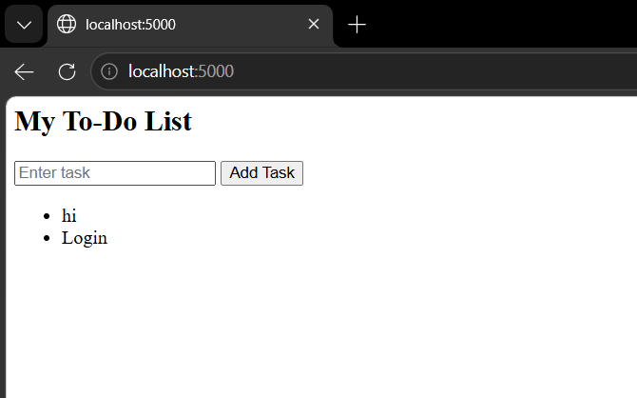
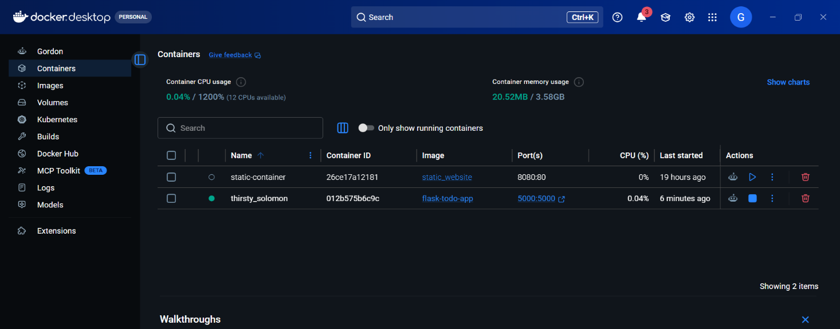
Result
Thus, The Flask To- Do app successfully containerized and deployed.

EXP- 22:
Push & Pull Docker Image
Aim
To demonstrate Docker image push and pull.
Procedure
1. create a folder docker-html-site.
2. create a html file named index.html. paste the html code in that file.
<!DOCTYPE html>
<html>
<head>
<title>My Docker Website</title>
</head>
<body>
<h1>Hello from Docker!</h1>
<p>This is my static HTML website running in Docker.</p>
</body>
</html>
3. create a docker file and paste the code. then save it.
FROM nginx:latest
COPY index.html /usr/share/nginx/html/index.html
4. click on new terminal and run this 'docker build -t my-html-site .'
5. check docker desktop to see the output.
6. in the terminal run 'docker run -d -p 8080:80 my-html-site'.
7. open browser and type 'http://localhost:8080'
8. After, in terminal run 'docker login'
9. after login tag the image like 'docker tag my-html-site username/my-html-site'.
10. to push image to docker hub run 'docker push username/my-html-site'
11. to pull the image run 'docker pull username/my-html-site'
12. run the pulled image 'docker run -d -p 8080:80 username/my-html-site'
13. open browser 'http://localhost:8080' to see the pulled image.
14. To see the no. of repositories type 'docker ps'
15. To see the no. of images in docker desktop type 'docker images'
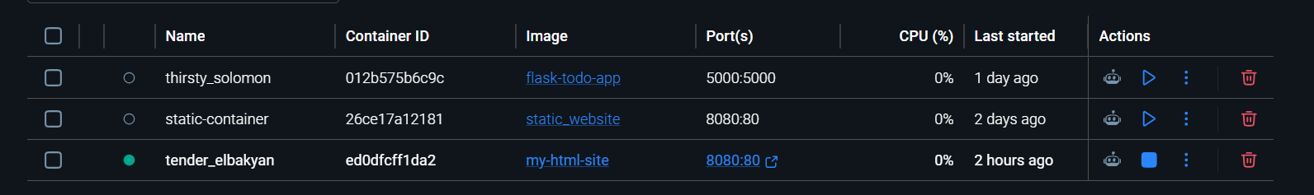
Result
Thus, The Docker image successfully pushed and pulled.

EXP- 23:
Multi- Container App with Kubernetes
Aim
To deploy multi- container app using Kubernetes.
Procedure
1. Create a folder named multi.app
2. create a file app.py and paste the code
from flask import Flask
app = Flask(__name__)
@app.route("/")
def home():
return "Backend API Running"
if __name__ == "__main__":
app.run(host="0.0.0.0", port=5000)
3. Create a file requiremnets.txt and write flask in it.
4. Create another file dockerfile and paste this code.
FROM python:3.9
WORKDIR /app
COPY . .
RUN pip install -r requirements.txt
EXPOSE 5000
CMD ["python","app.py"]
5. create a file backend-deployment.yaml and paste the code
apiVersion: apps/v1
kind: Deployment
metadata:
name: backend
spec:
replicas: 1
selector:
matchLabels:
app: backend
template:
metadata:
labels:
app: backend
spec:
containers:
- name: backend
image: yourusername/backend
ports:
- containerPort: 5000
6. Create another file frontend-deployment.yaml and paste the code
apiVersion: apps/v1
kind: Deployment
metadata:
name: frontend
spec:
replicas: 2
selector:
matchLabels:
app: frontend
template:
metadata:
labels:
app: frontend
spec:
containers:
- name: frontend
image: nginx
ports:
- containerPort: 80
7. create a file name mysqql-deployment.yaml and paste the code
apiVersion: apps/v1
kind: Deployment
metadata:
name: mysql
spec:
replicas: 1
selector:
matchLabels:
app: mysql
template:
metadata:
labels:
app: mysql
spec:
containers:
- name: mysql
image: mysql:5.7
env:
- name: MYSQL_ROOT_PASSWORD
value: password
ports:
- containerPort: 3306
8. create a file named services.yaml and paste the code
apiVersion: v1
kind: Service
metadata:
name: frontend-service
spec:
type: NodePort
selector:
app: frontend
ports:
- port: 80
targetPort: 80
nodePort: 30008

---

apiVersion: v1
kind: Service
metadata:
name: backend-service
spec:
selector:
app: backend
ports:
- port: 5000
targetPort: 5000

---

apiVersion: v1
kind: Service
metadata:
name: mysql-service
spec:
selector:
app: mysql
ports:
- port: 3306
9. Open the new terminal and run this commands
1.kubectl apply -f backend-deployment.yaml
2.kubectl apply -f frontend-deployment.yaml
3.kubectl apply -f mysql-deployment.yaml
4.kubectl apply -f services.yaml
10. run this in the terminal kubectl get services and open this http://localhost:30008 in browser
11. to check monitor deployment run kubectl get deployments and to check pods continuously run kubectl get pods -w
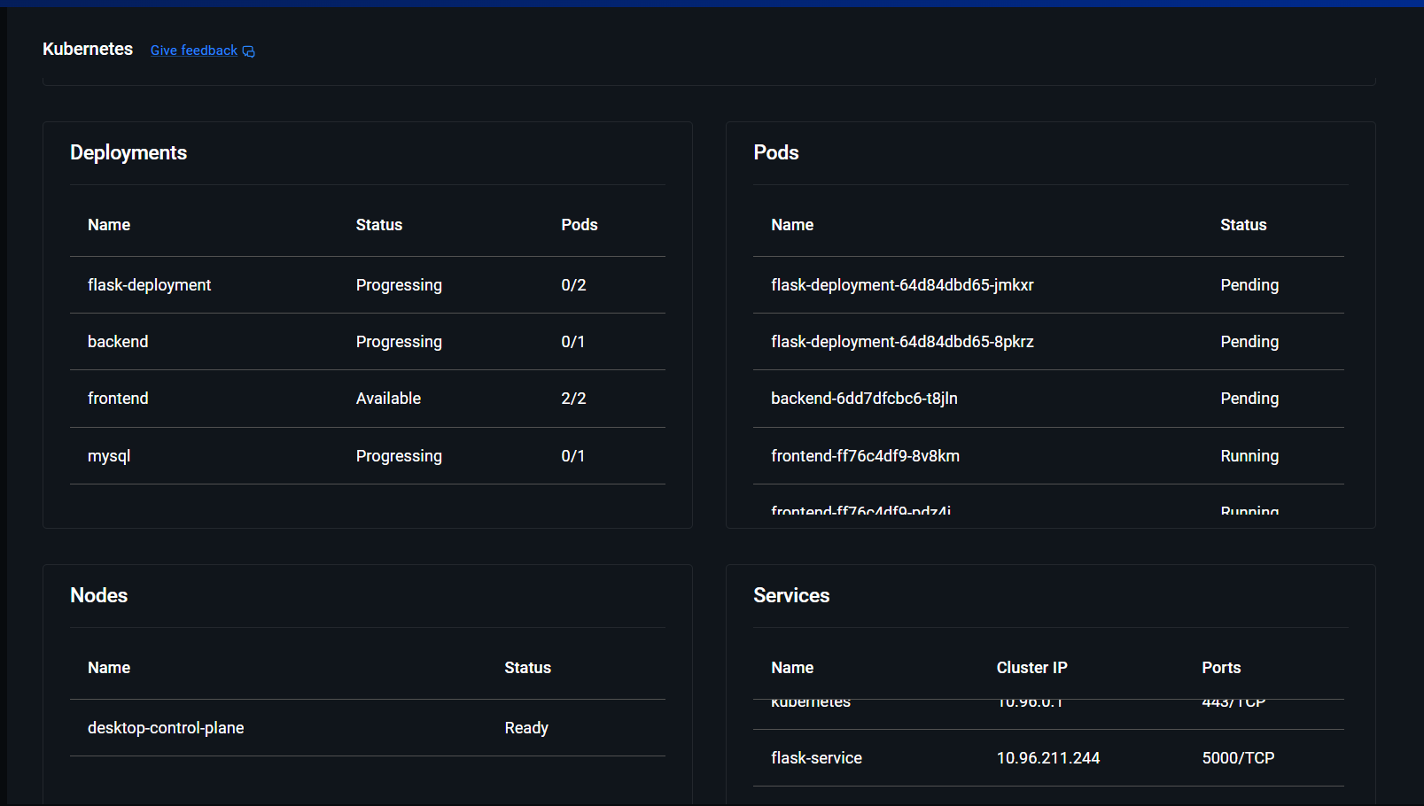
RESULT: Thus, The Multi- container application deployed and scaled successfully.

EXP- 24
CI/CD with GitHub Actions
Aim
To automate testing and deployment using GitHub Actions.
Procedure
- Create a folder named flask-cicd-app
- Open the folder in VS Code and create a file app.py and paste the code
from flask import Flask
app = Flask(__name__)
@app.route('/')
def home():
return "Flask CI/CD Pipeline Successful!"
if __name__ == "__main__":
app.run(host="0.0.0.0", port=5000)
- Create a file requirements.txt and write flask
- Create a file Dockerfile and paste the code
FROM python:3.9
WORKDIR /app
COPY requirements.txt .
RUN pip install -r requirements.txt
COPY . .
CMD ["python","app.py"]
- Open terminal and initialize git repository
git init
git add .
git commit -m "Initial commit"
- Open GitHub and create a new repository named flask-cicd-app
- Run the following commands in terminal
git remote add origin https://github.com/yourusername/flask-cicd-app.git
git branch -M main
git push -u origin main
- Click Create new file in GitHub and name it .github/workflows/ci-cd.yml
- Paste the workflow code and click Commit new file
name: Flask CI/CD Pipeline
on:
push:
branches: ["main"]
jobs:
build:
runs-on: ubuntu-latest
steps:
- name: Checkout code
uses: actions/checkout@v3
- name: Login to DockerHub
uses: docker/login-action@v2
with:
username: ${{ secrets.DOCKER_USERNAME }}
password: ${{ secrets.DOCKER_PASSWORD }}
- name: Build Docker Image
run: docker build -t ${{ secrets.DOCKER_USERNAME }}/flask-cicd-app .
- name: Push Docker Image
run: docker push ${{ secrets.DOCKER_USERNAME }}/flask-cicd-app
- Go to Actions tab in GitHub. You will see Flask CI/CD Pipeline Workflow running... Wait until the workflow completes.
- Open Settings → Secrets and variables → Actions. Click New repository secret. Add the first secret Name: DOCKER_USERNAME Secret: your docker hub username. Click Add secret.
- Add another secret Name: DOCKER_PASSWORD Secret: your docker hub password. Click Add secret.
- Modify the code in app.py in VS Code. Replace return "Flask CI/CD Pipeline Successful!" with return "CI/CD Deployment Successful!"
- Run the following commands in terminal
git add .
git commit -m "Updated application"
git push
- Go to GitHub → Actions You will see Flask CI/CD Pipeline Workflow triggered by push Pipeline runs automatically.
- Deploy the container locally (or on cloud) using Docker
docker login
docker build -t yourusername/flask-cicd-app .
docker push yourusername/flask-cicd-app
docker run -d -p 5000:5000 yourusername/flask-cicd-app
- Use the AWS Connect → SSH client instructions or run: ssh ubuntu@<your-ec2-public-ip>
- Install Docker on the Server Run: sudo apt update
sudo apt install docker.io -y
sudo systemctl start docker
- Pull the Image from Docker Hub docker pull yourusername/flask-cicd-app
- docker run -d -p 5000:5000 yourusername/flask-cicd-app
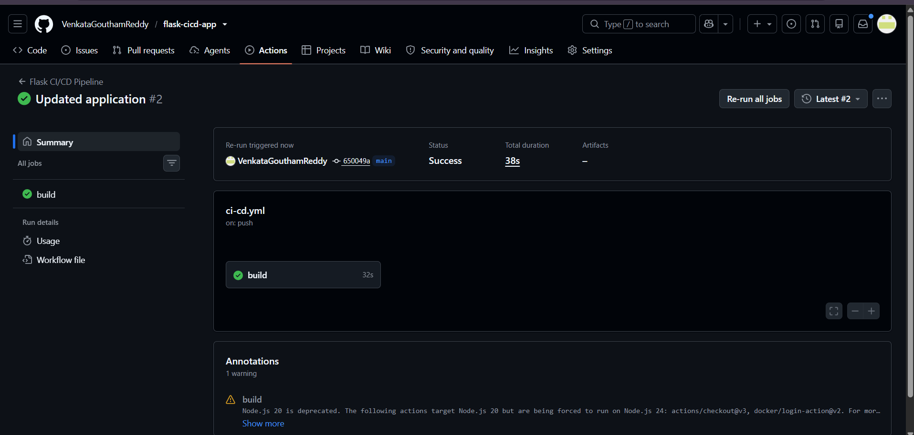
RESULT: Thus, The CI/CD pipeline executed successfully.
EXP- 25
Create GitHub Repository
Aim
To create and update a GitHub repository.
Procedure
1. Create a GitHub Repository Go to GitHub → Click New Repository Enter repository name Select Initialize with README.md Click Create Repository
2. Clone the Repository git clone https://github.com/your-username/repository-name.git cd repository-name
3. Edit README.md File Open the project in VS Code Modify README.md (example):
# My Project
This is a personal project created to demonstrate GitHub version control.
4. Stage Changes git add README.md
5. Commit Changes git commit -m "Updated README with project description"
6. Push Changes to GitHub git push origin main
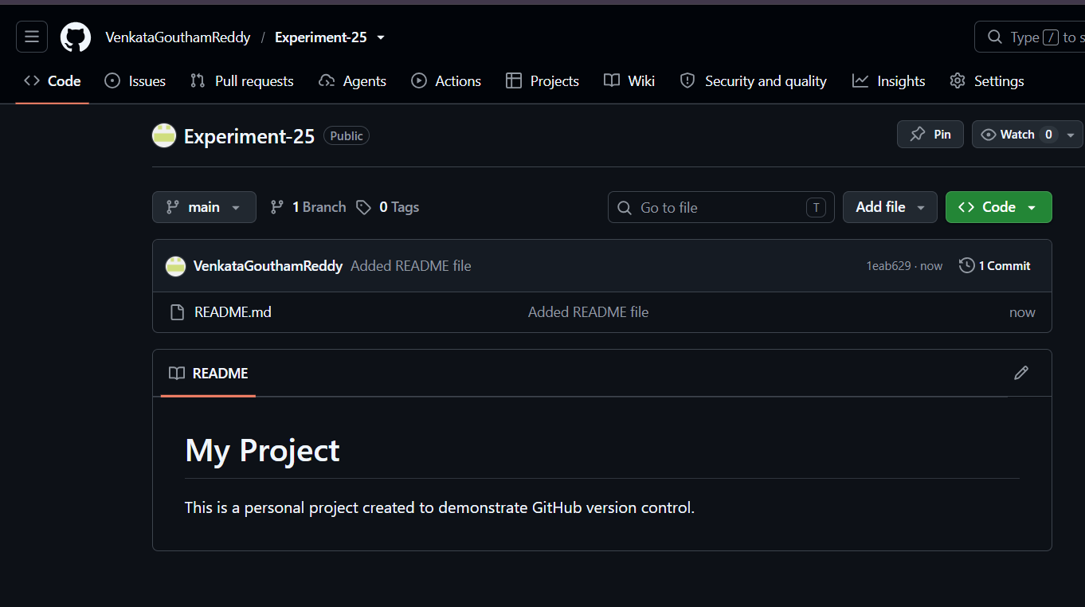
Result: Thus, The Merge conflicts resolved successfully and branch merged.

EXP- 26
Clone & Modify Repository
Aim
To clone and edit a GitHub repository.
Procedure
1. Choose a Repository Select any public GitHub repository (e.g., sample or personal repo) Copy the repository URL
2. Clone the Repository git clone https://github.com/username/repository-name.git
3. Navigate to Repository Folder cd repository-name
4. Open a File Open the project in VS Code or any editor Select a file (e.g., README.md or .py/.js file)
5. Make a Small Change Modify a line (example):
Before: This is sample project
After: This is a sample project (updated)
6. Save Changes Save the file using Ctrl + S
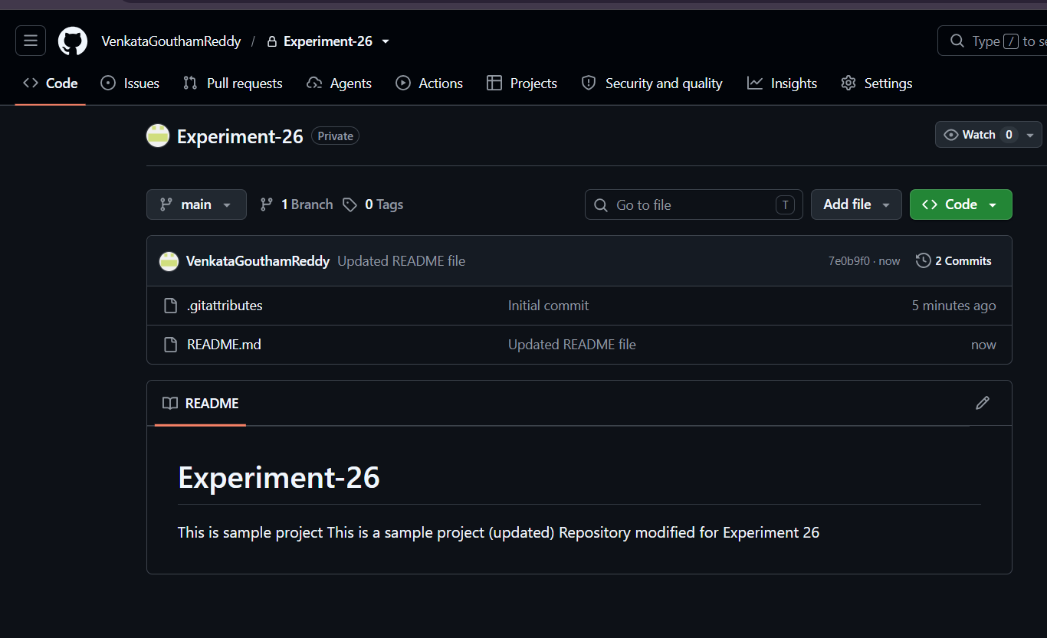
Result: Merge conflicts resolved successfully and branch merged.

Exp- 27:
Clone, Modify, Commit, and Push Changes Using GitHub Desktop
Aim
To perform version control operations using GitHub Desktop by cloning a repository, modifying files, committing changes, and pushing updates to the remote repository.
Procedure
- Install and open GitHub Desktop on the system.
- Sign in using a GitHub account.
- Select File → Clone Repository and choose the required repository from GitHub.
- Select the local folder location and click Clone to download the repository.
- Open the cloned project folder using a code editor.
- Modify the required files and save the changes.
- Return to GitHub Desktop and review the changed files under the Changes tab.
- Enter a commit message describing the modifications made.
- Click Commit to main (or the current branch) to save changes locally.
- Click Push Origin to upload the committed changes to the GitHub remote repository. 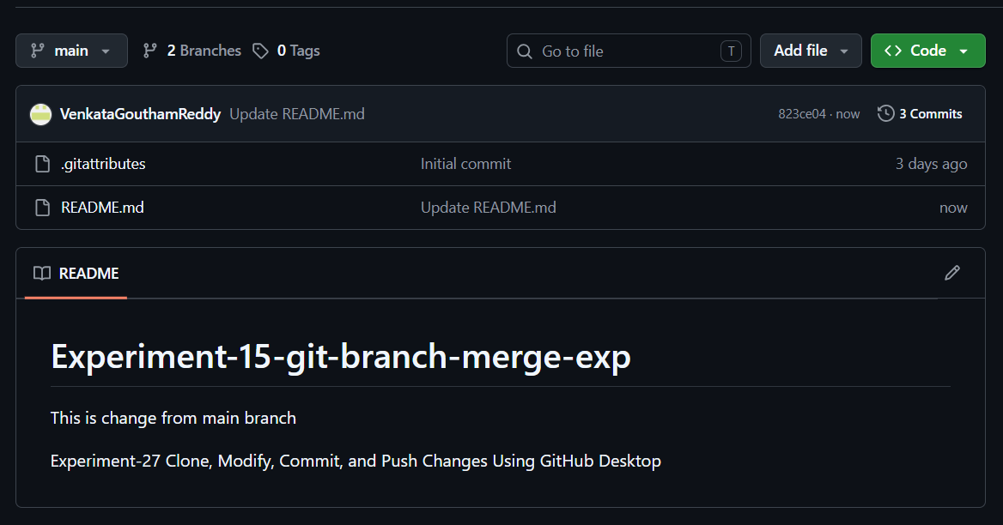
Result
Thus, the repository was successfully cloned, modified, committed, and pushed to the remote repository using GitHub Desktop, enabling effective version control and collaboration.
Exp- 28:
Pull Latest Changes from GitHub Using GitHub Desktop
Aim
To update the local repository by pulling the latest changes from the remote GitHub repository using GitHub Desktop.
Procedure
- Open GitHub Desktop on the system.
- Sign in to the GitHub account if not already signed in.
- Select the previously cloned repository from the repository list.
- Ensure the correct branch (such as main) is selected.
- Click Fetch Origin to check for updates available in the remote repository.
- If changes are available, click Pull Origin to download and merge the latest updates into the local repository.
- Wait until the pull operation is completed successfully.
- Open the local project folder and verify that the latest files and changes are updated.
- Resolve merge conflicts if prompted and save the final changes.
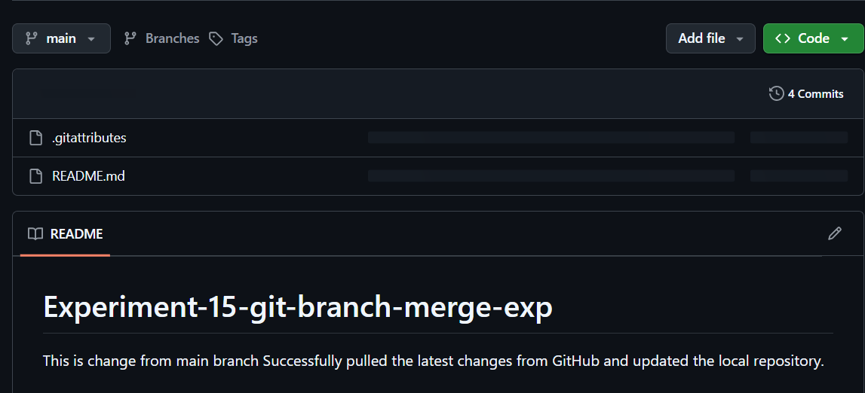
Result
Thus, the latest changes from the remote GitHub repository were successfully pulled and updated in the local repository using GitHub Desktop, ensuring synchronization with collaborator updates.

Exp-29:
GitHub Branching and Pull Request Experiment
Aim
To create and manage branches in GitHub, make changes independently, and create a Pull Request to merge changes into the main branch.
Procedure
- Open GitHub Desktop and sign in to the GitHub account.
- Clone the required repository or open an existing local repository.
- Create a new branch by selecting Current Branch → New Branch.
- Enter the branch name and create the branch.
- Open the project files and make the required modifications.
- Save the changes and return to GitHub Desktop.
- Review the modified files under the Changes tab.
- Enter a commit message and click Commit to [branch name].
- Click Push Origin to upload the branch changes to GitHub.
- Open the GitHub repository in a browser and click Compare & Pull Request.
- Add a title and description for the Pull Request.
- Click Create Pull Request and review the changes.
- Merge the Pull Request into the main branch if approved.
- Verify that the changes are updated in the repository.
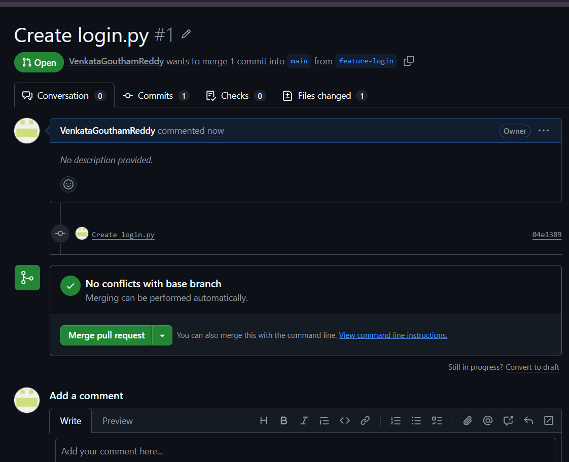
Result
Thus, branching and Pull Request operations were successfully performed using GitHub, enabling independent development, code review, and controlled merging of changes into the main repository.

Exp- 30:
GitHub collaboration workflow
Aim
To fetch the latest changes from a GitHub repository, create a new branch, implement a new feature independently, and manage the changes using Git version control without affecting the existing code.
Procedure
- Open Visual Studio Code and launch the integrated terminal.
- Navigate to the existing project repository folder.
- Pull the latest changes from GitHub using the pull command to update the local repository.
- Create a new branch for implementing the new feature.
- Open project files and add or modify the required feature files.
- Save the changes in the project.
- Check the repository status to view modified and new files.
- Stage the modified files using the add command.
- Commit the changes with an appropriate commit message.
- Push the new branch to the GitHub repository.
- Open GitHub and create a Pull Request to merge the feature branch into the main branch.
- Review and merge the Pull Request after verification.
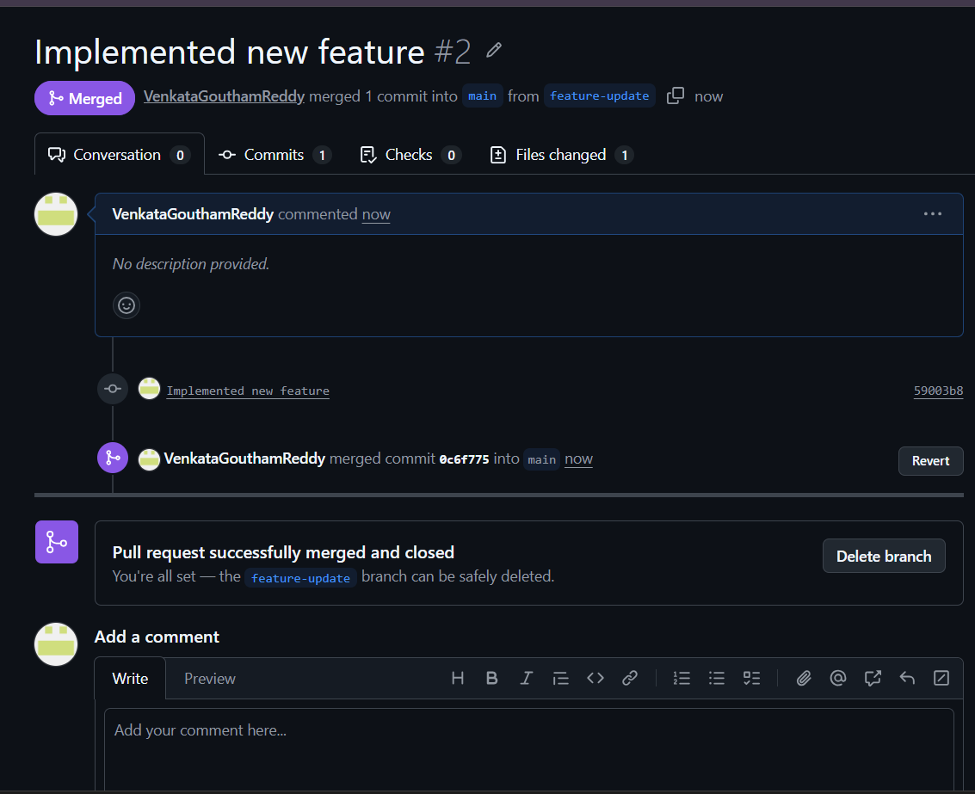

Result
Thus, the latest project changes were fetched successfully, a new branch was created, the feature was implemented independently, and the changes were integrated into the project using GitHub version control workflow.

